A

**Project Report**

On

**“QUICKRICKSHAW”**

Submitted by

**RAVENDRA PRATAP (228204)**

**SAVITENDRA MANI PANDEY (228205)**

**ABHAY YADAV (228201)**

**VIJAY VEER SINGH (228206)**

Submitted to

**Dr. Arvind Kumar Tiwari Prof. Dhirendra Kumar**

For Partial Fulfilment of Award of Degree In

**Bachelor of Technology**

At



**Department of Computer Science & Engineering**

**Kamla Nehru Institute of Technology, Sultanpur**

**(An Autonomous Government Institute)**

**Affiliated to**

**Dr. A.P.J. Abdul Kalam Technical University, Lucknow, U.P.**

**(2024-2025)**

**Declaration**

We hereby declare that this submission is our own work and that, to the best of our knowledge and belief, it contains no material previously published or written by another person or material which to a substantial extent has been accepted for the award of any other degree or diploma of the University or other institute of higher education, except where due acknowledgement has been made in the text.

**Abhay Yadav** (228201)

**Ravendra Pratap** (228204)

**Savitendra Mani Pandey** (228205)

**Vijay Veer Singh** (228206)

**CERTIFICATE**

This is to certify that **Abhay Yadav (228201), Ravendra Pratap (228204)**, and **Savitendra Mani Pandey (228205), Vijay Veer Singh (228206)** have carried out the project work in this report entitled “**QuickRickshaw**” for the award of Bachelor of Technology in Computer Science and Engineering from Department of Computer Science and Engineering, Kamla Nehru Institute of Technology, affiliated to Dr. A. P. J. Abdul Kalam Technical University, Lucknow.

This report is the record of the candidates’ own work carried out by them under our supervision and guidance. The project report embodies results of original work, and studies are carried out by the students themselves, and the contents of the project report do not form the basis for the award of any other degree to the candidates or to anybody else from this or any other University/Institution. Their performance was excellent, and we wish them good luck for their future endeavours.

**_____________________ ___________________ ___________________**

**Dr. Arvind Kumar Tiwari Prof. Dhirendra Kumar Dr. Arvind Kumar Tiwari**

(Supervisor 1) (Supervisor 2) (Head of Department)

**ACKNOWLEDGEMENT**

We wish to express our sincere gratitude to **Dr. Arvind Kumar Tiwari** (Supervisor) for his valuable suggestions and guidance throughout our work at Kamla Nehru Institute of Technology, Sultanpur. He has guided us through the difficulties and made us understand the concepts needed for the project work. Their experimental and theoretical knowledge has been very helpful. We feel privileged in expressing our gratitude to all faculty members of computer science and engineering department for their encouragement and moral support.

We would like to thank **Prof. Dhirendra Kumar** (Additional Supervisor) for providing us a golden opportunity to work with him. The support and then environment provided to us during our project was more than what anyone would have expected.

We are also deeply indebted to all those without whose firm support encouragement and guidance, this project would have seen this stage.

**Abhay Yadav** (228201)

**Ravendra Pratap** (228204)

**Savitendra Mani Pandey** (228205)

**Vijay Veer Singh** (228206)

**ABSTRACT**

**QuickRickshaw** is a full-stack web application developed to digitize and streamline the process of booking rickshaws in urban and semi-urban areas. In many cities, rickshaw transportation remains a primary means of short-distance travel, yet the process of hiring one often involves manual effort, unpredictability, and lack of transparency. This project addresses these issues by providing a **real-time, user-friendly platform** where customers can book rides quickly and conveniently, and rickshaw drivers can manage bookings efficiently.

Developed using the **MERN stack** — **MongoDB** for the database, **Express.js** and **Node.js** for the backend, and **React.js** for the frontend — Quick Rickshaw ensures a modern, scalable, and responsive user experience. The system supports core functionalities such as **user and driver authentication**, **ride booking**, **ride request management**, **ride history**, and **real-time ride updates**. Users can create an account, view available drivers, book a ride, and receive updates on ride status. On the other side, drivers can accept or reject ride requests based on their availability.

The application follows a modular architecture and adheres to RESTful API standards, ensuring maintainability and future scalability. It aims to enhance the efficiency of rickshaw transportation, reduce waiting times, and introduce digital convenience into a traditionally offline system. The project has potential for further development, including **GPS integration**, **in-app payments**, **fare estimation**, and **ride-sharing options**, making it a promising step toward smart city transportation solutions.

**TABLE OF CONTENT**

1. **INTRODUCTION …………………………………………………………1**

1.1 Overview of Project **……………………………....………………..…**1 1.2 Motivation **……………………………………………………………**2 1.3 Objectives **……………………………………….………………………**2

**2. LITERATURE SURVEY ………………………………………………….4**

* 1. Introduction **………………………………………………………..……**4
  2. Background and Existing Systems **…………………….………………..**4
  3. Core Problems in the Current System **…………………………………..**5
  4. Technology Selection – MERN Stack **………………………………….**5
  5. Key Features Addressing Core Problems **………………………………**6
  6. Real-Time Communication and Location Tracking **……………………**6
  7. Security and Role-Based Access **……………………………………….**7
  8. UI/UX Considerations **……………………………………………….....**7
  9. Expandability and Smart City Integration **……………….……………..**7

**2.10 Summary Table of Key Aspects ……………………………………….8**

1. **EXISTING MODELS ……………………………………………………..9** 
   1. Uber & Ola **……………………………………………………..………**9
   2. Rapido **………………………………………………………………….**9
   3. In Drive **………………………………………………………………..**10
   4. SmartAuto **……………………………………………………………..**11
   5. Summary Table **………………………………………………………..**12
   6. Market Gap and Scope **………………………………………………..**13
2. **DESIGNED MODEL ………………………………………….…………14** 
   1. Methodology **…………………………………………………………..**14
   2. System Architecture **………………………………………………...…**14
   3. Frontend Design **……………………………………………………….**15
   4. Responsive Design **……………………………………………………**15
   5. Backend and API Logic **………………………………………………**16
   6. Authentication and Middleware **………………………………………**16
   7. RESTful API Design **…………………………………………..….…..**16
   8. Database Design **…………………………………………………....…**17
   9. Data Structure & Indexing **………………………………..………......**17

4.10 Real-Time Communication **………………………….……..…..……**17

4.11 Security and Role Management **………………………………..……**18

4.12 Scalability and Future Scope **………………………………………..**18

1. **SYSTEM REQUIREMENTS………………..………………….………19** 
   1. Hardware Requirements **……………………………………….……..**19
   2. Software Requirements **………………………………….……………**19
   3. Non-Functional Requirements **…………………………………….….**20
2. **RESULTS AND DISCUSSION………………………………………….21** 
   1. Functionality Overview **…………………………………………….…**21
   2. Admin and Database Integrity **………………………………………...**21
   3. Performance Evaluation **……………………………………...……….**22
   4. Usability and User Experience **……………………….……...……….**22
   5. Security & Reliability **……………………….……………..…...…….**23
   6. Comparison with Existing Systems **…….………………….………....**23
   7. Limitations Observed **……………………………………….………..**24
   8. Scalability and Future Scope **…………………………….…………..**24
   9. Summary of Results **……………………………………………...…...**26
3. **SYSTEM DESIGN AND MODELLING ………………………………27** 
   1. Use Case Diagram **…………………………………………....….……**27
   2. Activity Diagram **……………………….………...……..…...………..**28
   3. Sequence Diagram **…………………………………………………....**30
   4. Data Flow Diagram **……….………………………………….………**31
   5. Entity–Relationship Diagram **………………………………………...**32
4. **SYSTEM IMPLEMENTATION AND SCREENSHOTS ....…….….34** 
   1. Screenshots **…………………………………………....…..………..**34

# CONCLUSION AND FUTURE SCOPE …………………...………..39

* 1. Conclusion **…….…………………………………………....….……**27
  2. Future Scope **……………………….………...……..…...…………..**28

1. **REFERENCES ……………………………….…………………….…42**

**LIST OF FIGURES**

Fig. 1: Backend Architecture 16

Fig. 2: Use Case Diagram Representation 27

Fig. 3: Activity Diagram Representation 29

Fig. 4: Sequence Diagram 23

Fig. 5: Data Flow Diagram Level -0 31

Fig. 6: Data Flow Diagram Level -1 32

Fig. 7: ER Diagram Representation 33

Fig. 8: User Registration and Login 34

Fig. 9: USER/CAPTAIN Home Page 35

Fig. 10: Auto Suggestions GOMAPS API (Source)Page 35

Fig. 11: Auto Suggestions GOMAPS API (Destination)Page 36

Fig. 12: Fare Display Page 36

Fig. 13: Confirm Ride PopupPage 37

Fig. 14: Accept Ride PopupPage 37

Fig. 15: Complete RidePage 38

Fig. 16: Database Representation 38

**LIST OF TABLES**

Table 1: Core Problem in Current System 5

Table 2: **Key Features Addressing Core Problems** 6

Table 3: Summary Table of Key Aspects 8

Table 4: **Comparison with Existing Models 12**

Table 5: **Summary of Combine Results 26**

# INTRODUCTION

## The rise in urban population has led to an increase in demand for efficient and affordable transportation systems. Traditional rickshaw services, while accessible, often lack structure, leading to long wait times, inefficient routing, and inconsistent pricing. To address these challenges, Quick Rickshaw is proposed as a smart transport application that leverages Mobile Edge Radio Technology (MERT) to deliver fast, low-latency, and location-aware rickshaw booking services.

## Quick Rickshaw functions as a bridge between passengers and nearby rickshaw drivers, enabling real-time booking, GPS tracking, and fare estimation. Unlike traditional cloud-based systems, this app uses MERT to process data closer to the user through edge computing, reducing response time and improving service reliability. This integration is particularly beneficial in congested or low-connectivity environments where traditional apps may struggle.

## 1.1 Overview of Project

## Transportation is a vital aspect of modern urban life, directly impacting accessibility, convenience, and the daily routines of people living in cities and semi-urban areas. While auto-rickshaws and e-rickshaws are one of the most widely used modes of transport for short-distance travel in many countries, the sector remains highly unorganized. Riders frequently face challenges such as inconsistent availability, lack of fare transparency, and no proper mechanism to locate or book rides in real time. Addressing these challenges through digital transformation is the foundation of our project — Quick Rickshaw, a full-featured transportation web application built using the MERN stack.

## Quick Rickshaw is a modern, scalable, and efficient rickshaw booking platform developed using MongoDB, Express.js, React.js, and Node.js. The system aims to digitize and organize the rickshaw service model, offering passengers the ability to book rides online while allowing rickshaw drivers to respond to nearby ride requests using a web interface. The platform ensures smoother ride bookings, accurate fare estimations, and live tracking capabilities, thereby streamlining urban mobility.

## The choice of the MERN stack plays a crucial role in the performance and structure of the application. React.js provides a dynamic, fast, and user-friendly frontend for both riders and drivers. Node.js, along with Express.js, powers the backend server, handling API requests, authentication, and business logic. MongoDB, a NoSQL database, is used for storing user data, ride records, and system logs in a flexible and scalable manner.

## 1.2 Motivation

### Urban commuters often face difficulties with unregulated rickshaw services—such as fare disputes, availability issues, and lack of ride transparency. While cab services like Uber and Ola have solved some of these issues, they are often unaffordable for short-distance commuters and do not fully cater to the lower-income segment that depends on rickshaws.

### Moreover, most transport apps rely heavily on centralized cloud systems, which can experience high latency or service interruptions, especially in remote or high-traffic areas. This sparked the idea to integrate MERN Technology, which processes data at the network's edge to provide faster and more reliable service. The project was motivated by a desire to blend technology with grassroots mobility needs, bringing smart solutions to traditional transport in a cost-effective manner.

### 1.3 Objective

The primary objective of the "Quick Rickshaw" project is to design and develop a full-stack web application that enables users to book rickshaw rides efficiently and reliably using modern web technologies. Built using the MERN stack (MongoDB, Express.js, React.js, and Node.js), the application aims to provide a smart, digital platform that connects passengers with local rickshaw drivers in real time.

The project seeks to transform the traditional rickshaw transportation system by eliminating the need for middlemen and long wait times, thereby improving accessibility, transparency, and convenience. It provides two user roles—passengers and drivers—each with its own dashboard and features, including ride booking, driver availability, route tracking, and fare estimation.

Quick Rickshaw emphasizes a responsive and user-friendly interface for smooth operation across devices, as well as secure authentication, dynamic data handling, and live ride tracking through location-based services. The project also focuses on real-time notifications, ride history management, feedback collection, and scalable deployment.

In addition, the system is designed to support future enhancements such as payment gateway integration, ride-sharing, and multilingual access, making it a flexible and sustainable transport solution for smart city development.

# 2. LITERATURE SURVEY

**2.1 Introduction**

Urban and semi-urban mobility remains a major challenge in developing nations, especially in areas reliant on informal transport like auto-rickshaws. Traditional rickshaw systems lack digitalization, causing inefficiencies in ride booking, fare management, driver allocation, and customer convenience.

The *QuickRickshaw* project aims to bridge this gap by building a responsive and intelligent web-based transport solution using the **MERN (MongoDB, Express.js, React.js, Node.js)** stack. This system ensures real-time ride booking, live location tracking, digital records, and two-role management (drivers and passengers) through a scalable, full-stack web architecture.

**2.2 Background and Existing Systems**

**2.2.1 Commercial Ride Platforms**

* Uber, Ola, Rapido offer ride-hailing but mostly exclude local rickshaw operators.
* Operate on centralized models with high commission fees and strict driver onboarding processes.
* Not suited for informal local drivers, leading to exclusion of rickshaws from the digital ecosystem.

**2.2.2 Academic Attempts**

* **Smart Auto** (2018): Android-based frontend rickshaw portal – Lacked Backend.
* **Ride Mate** (2020): React App with booking interface – no real-time communication or role separation.
* Weak in database integration, scalability, and user authentication.

**2.3 Core Problems in the Current System**

| **Identified Problem** | **Description** |
| --- | --- |
| No Booking System | Passengers must physically hail rickshaws. |
| Income Inconsistency | Drivers waste time waiting without passengers. |
| No Transparency | No fare standardization or location tracking. |
| No Ride History | Passengers/drivers lack ride and earnings records. |
| No Digital Interface | No accessible, scalable system tailored to local rickshaws. |

Table 1: Core Problem in Current System

**2.4 Technology Selection – MERN Stack**

**2.4.1 MongoDB**

* NoSQL database suitable for flexible user and ride data.
* Supports dynamic collections (e.g., rides, feedback, users).
* Easily scales for large data volumes.

**2.4.2 Express.js + Node.js**

* Efficient API layer to handle:
  + User authentication (JWT-based).
  + Booking requests and responses.
  + Ride updates and notifications.
* Event-driven nature handles high traffic in real time.

**2.4.3 React.js**

* Enables dynamic UI for passengers and drivers.
* Component reusability simplifies development.
* Supports responsiveness (mobile-friendly experience).

## ****2.5. Key Features Addressing Core Problems****

| **Problem Statements** | **Solution via QuickRickShaw** |
| --- | --- |
| No Booking System | Ride booking via interactive frontend. |
| No Transparency | Live GPS tracking, digital receipts. |
| Driver Idle Time | Real-time ride requests and notifications. |
| No Ride History | MongoDB stores ride data with timestamps. |
| No Interface | MERN-based responsive web interface. |

Table 2: **Key Features Addressing Core Problems**

**2.6. Real-Time Communication and Location Tracking**

* Integration of Google Maps API or Map box:
  + Shows available rickshaws in user vicinity.
  + Tracks movement during rides.
* **WebSocket’s / Firebase** for:
  + Real-time ride status updates.
  + Driver alerts when ride requests come in.
  + Passenger updates (driver end route, ride started, etc.).

**2.7.** **Security and Role-Based Access**

* Uses **JWT** for secure login sessions.
* Passwords hashed using **bcrypt**.
* Roles:
  + Passenger: Can register, login, book ride, track ride.
  + Driver: Accept/reject rides, update availability.
* RBAC (Role-Based Access Control) ensures UI and database are secure and role-specific.

**2.8.** **UI/UX Considerations**

* Built using **React +** Tailwind **CSS**.
* Separate dashboards:
  + Driver Dashboard: Rides list, earnings, availability toggle.
  + Passenger Dashboard: Bookings, live status, history.
* Designed to support future PWA/mobile app conversion.

**2.9. Expandability and Smart City Integration**

* Designed to support:
  + Live Tracking
  + Auto Suggestions
* Integration with Maps API

## ****2.10. Summary Table of Key Aspects****

| **Aspect** | **Technology / Solution** | **Description** |
| --- | --- | --- |
| Stack | MERN (MongoDB, Express, React, Node) | Full JavaScript stack with scalable, real-time architecture. |
| Database | MongoDB | NoSQL storage for users, rides, feedback, etc. |
| Authentication | JWT + bcrypt | Secure, token-based login and session management. |
| UI Framework | React + Tailwind | Modern, responsive, component-based frontend. |
| Communication | WebSocket’s / Firebase | Real-time updates for booking, status changes. |
| GPS & Mapping | Google Maps API / Map box | Live tracking of drivers and ETA calculation. |
| User Roles | RBAC | Two main dashboards: Driver and Passenger. |
| Real-Time Features | Ride alerts, live tracking,  Ride status updates | Seamless user experience. |
| Deployment | Cloud-Ready | Scalable via platforms like Vercel, Heroku, or AWS. |
|  | Table 3: Technology **Summary** |  |
|  |  |  |
|  |  |  |

# 3. EXISTING MODELS

#### 3.1. Uber & Ola

#### 3.1.1 Description:

#### Both are extensions of popular ride-hailing apps Uber and Ola, offering auto-rickshaw services.

#### Users can book auto rides via the app just like cabs, with live tracking and fare estimation.

#### 3.1.2 Scope:

#### Integration with advanced maps and payment gateways.

#### Available in major cities (Tier-1 & Tier-2).

#### Offers real-time GPS tracking, secure digital payments, and estimated fares.

#### 3.1.3 Limitations:

#### High commission cuts reduce rickshaw driver earnings.

#### Only registered rickshaws with smartphone access can participate.

#### Not accessible in many semi-urban or rural areas.

#### Lacks direct support for low-end or local driver requirements.

#### 3.1.4 Improvement in Quick Rickshaw:

#### Focuses on affordability and local driver inclusion.

#### Lightweight MERN stack app with low hardware requirements.

#### Tailored dashboard for rickshaw drivers with minimal training required.

**3.2 Rapido**

**3.2.1 Description:**

* College-level Android app for rickshaw tracking and booking.
* Featured basic ride request forms and GPS pinning.

**3.2.2 Scope:**

* Shows potential for micro-mobility support.
* Introduces real-time thinking in small transport systems.

**3.2.3** **Limitations:**

* No backend/database integration.
* No authentication or data persistence.
* Poor UI/UX, lacked scalability and real-time responsiveness.

**3.2.4 Improvement in QuickRickShaw:**

* Full MERN stack backend with authentication and ride history.
* Real-time data updates using Web Sockets.
* Beautiful UI using React and Tailwind CSS, suitable for public deployment.

**3.3 In Drive**

**3.3.1 Description:**

* Focused on GPS-based tracking of autos using GOMAPS API.
* Aimed at enhancing location awareness.

**3.3.2 Scope:**

* Good focus on real-time GPS updates.
* Considered driver-side presence and location display.

**3.3.3 Limitations:**

* No booking system or UI flow.
* Limited to hardware-GPS integration.
* No user registration, database, or scalable logic.

**3.3.4 Improvement in Quick Rickshaw:**

* Offers complete booking flow, database persistence, and full frontend/backend separation.
* Real-time live location integration using APIs instead of using other demo features.

**3.4.** **SmartAuto**

**3.4.1 Description:**

* Focused on more beautiful advance user interface and user experience.
* Aimed at enhancing location awareness.

**3.4.2 Scope:**

* Good focus on real-time GPS updates.
* Considered driver-side presence and location display.

**3.4.3 Limitations:**

* No verification right now using OTP.
* Limited to hardware-GPS.
* No user registration, now integrate using MongoDB and for frontend smooth transition using ReactJS.

**3.4.4 Improvement in QuickRickshaw:**

* Offers complete booking flow, database persistence, and full frontend/backend separation.
* Real-time APIs instead of using older GPS integration.

#### 3.5 Summary Table

| Feature | Uber/Ola | Rapido | Indrive | RickshawWala | QuickRickShaw |
| --- | --- | --- | --- | --- | --- |
| Focus on Rickshaws | Partial | Full | Full | Full | Full |
| Real-Time Booking | Yes | Yes | No | Limited | Yes |
| Role-Based UI | No | No | No | No | Yes |
| Open Source/Customizable | No | No | Yes | Yes | Yes |
| Suitable for Local Deployment | No | Partial | No | Partial | Yes |
| Real-Time Location Tracking | Yes | Yes | Yes | Limited | Yes |
| Secure Login/Auth | Yes | Yes | No | No | Yes (JWT) |
| Scalable Architecture | Yes | No | No | No | Yes (MERN) |
| Offline/Low-End Support | No | No | Partial | No | Yes |

#### 

#### Table 4: **Comparison with Existing Models**

**3.6 Market Gap and Scope**

QuickRickShaw fills a critical gap in informal transportation systems where digital solutions have not yet penetrated. It’s scalable for college campuses, municipalities, or even NGOs looking to promote sustainable urban mobility. Unlike commercial platforms, it offers open-source code for further academic enhancement, social use, or startup adoption.

With sustainability as a goal, the system can eventually support shared rickshaw pooling, route optimization using AI, and a smart analytics dashboard for local transport authorities to monitor peak demand areas, user satisfaction, and driver income levels.

In conclusion, QuickRickShaw stands apart by providing a truly inclusive, affordable, and locally customizable transport tech solution—something existing models have yet to fully offer, especially for India’s underserved rickshaw community.

# 4. DESIGNED MODEL

## 4.1 Methodology

The QuickRickShaw project is designed to address urban and semi-urban transportation challenges by enabling a smart, real-time rickshaw booking system. Built using the MERN **stack**—MongoDB,Express.js,React.js**,** andNode.js—this system ensures responsiveness, flexibility, scalability, and security for both passengers and drivers.

The project methodology involves modular and layered system design, component-based frontend development, and secure backend API architecture. It follows a user-centric and mobile-first approach that allows easy adoption even among non-technical users like rickshaw drivers.

## 4.2 System Architecture

#### 4.1.3 Three-Tier Architecture

#### QuickRickShaw is developed using a three-tier system architecture that separates

#### responsibilities across three layers:

#### Frontend Layer: Built with React.js, this layer presents the user interface for passengers and drivers.

#### Backend Layer: Built with Node.js and Express.js, this layer handles business logic, API routing, and system integration.

#### Database Layer: Managed by MongoDB, this layer stores persistent data like users, drivers, rides, and feedback.

#### These layers communicate through RESTful APIs, ensuring loose coupling and efficient

#### data transfer. The architecture supports horizontal scaling and modular upgrades,

#### making the platform easy to extend and maintain.

## 4.3 Frontend Design

#### 4.3.1 Technology and Frameworks

## The frontend is developed using React.js for fast rendering and Tailwind CSS for responsive

## styling. This ensures a seamless and consistent user experience across mobile and desktop

## devices.

#### 4.3.2 User Roles and Interfaces

* Passenger Interface:
  + Registration and login
  + Location input (pickup and drop)
  + Ride booking interface
  + Real-time ride tracking
  + Ride history and feedback submission
* Driver Interface:
* Registration and login
* Cash Availability
* Accept/reject ride requests
* View ride and Live location Each interface is built using modular components such as forms, tables, and cards, making the system easier to test and maintain.

## 4.4 Responsive Design

The entire interface is **mobile-first**, catering to smartphone users. The UI is designed to be intuitive even for people with low digital literacy. Accessibility and minimalism are key design principles, with high contrast, large tap areas, and clear call-to-action buttons.

## 4.5 Backend and API Logic

**4.5.1 Node.js + Express Backend**

The backend is developed with **Node.js** for asynchronous request handling and Express.js

for structured routing. It manages:

* User/driver registration and authentication
* Ride booking and tracking
* Driver availability and response handling
* Real-time data synchronization

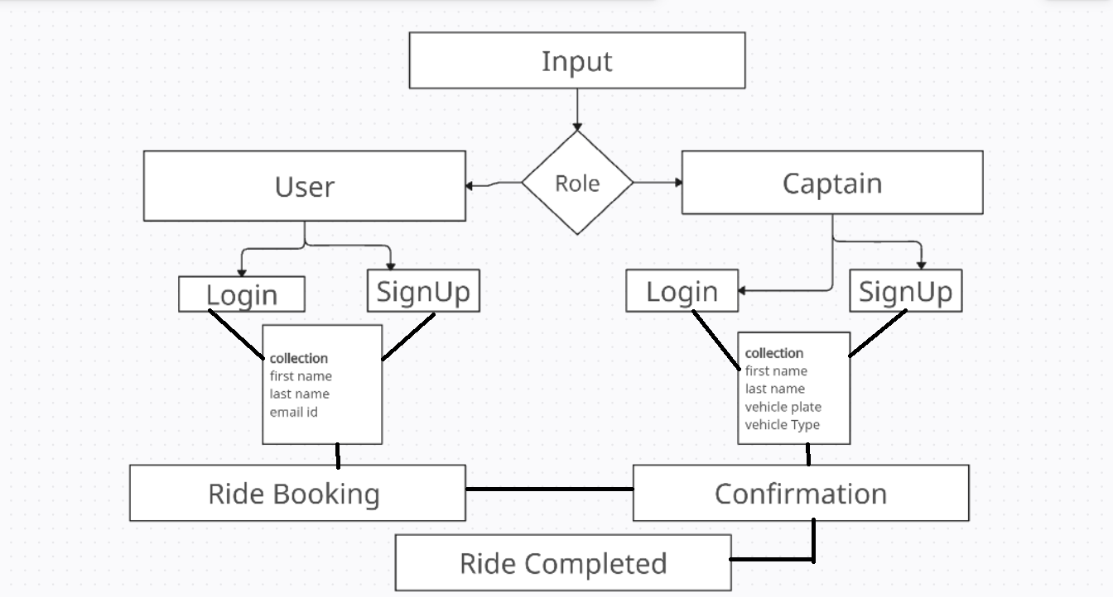

Fig. 1: Backend Architecture

## 4.6 Authentication and Middleware

* JWT (JSON Web Token) is used for session-based authentication.
* bcrypt.js is used to hash passwords before storing them.
* Middleware ensures that only authenticated users can access protected routes.
* Role-based access control is implemented to separate driver and passenger functionalities.

## 4.7 RESTful API Design

All operations are exposed through **REST APIs** using clear and predictable endpoints. Example:

* POST /api/book-ride – Book a new ride
* GET /api/rides/history – Fetch ride history
* PATCH /api/driver/status – Update availability

## 4.8 Database Design

**4.8.1 Collections in MongoDB**

The system uses MongoDB, a document-oriented NoSQL database that supports fast,

flexible data modelling. Key collections include:

* Users: Stores personal info, login credentials, and linked rides status.
* Drivers: Contains status (available) and assigned rides.
* Rides: Logs pickup/drop location, status, and IDs of passenger and driver.

## 4.9 Data Structure & Indexing

Documents are linked using ObjectIDs. Fields like location, availability, and status are indexed for faster queries (e.g., nearby available drivers).

## 4.10 Real-Time Communication

**4.10.1 Live Updates via web Sockets**

Real-time ride status tracking is achieved using web Sockets or Firebase RealtimeDatabase.

* Notifying drivers of new ride requests
* Live status updates during the ride (e.g. arrived, completed)
* Instant notifications for passengers

## 4.11 Security and Role Management

**4.11.1 Encryption and Data Protection**

* bcrypt encrypts passwords before storage.
* JWTs manage secure access tokens for frontend-backend communication.
* API routes are protected through middleware and access control.

## 4.12 Scalability and Future Scope

**4.12.1 Modular Design for Future Features**

The system is designed for future growth and enhancements such as:

* Digital payments (UPI, wallets)
* Multilingual support for regional users
* Progressive Web App (PWA) version for offline use
* Driver verification, SOS alerts, and customer support chat

The codebase and data model support these features without major structural changes.

# 5.SYSTEM REQUIREMENTS

To ensure smooth development, deployment, and operation of the QuickRickShaw smart rickshaw booking platform, it is essential to define both hardware and software system requirements. The system is built using the MERN stack (MongoDB, Express.js, React.js, Node.js) and is designed to be responsive, scalable, and secure. The following requirements are categorized into functional and non-functional aspects.

## 5.1 Hardware Requirements

**5.1.1 For Developers**

## Processor: Intel i5 or higher (or AMD equivalent)

## RAM: Minimum 8 GB

## Storage: Minimum 256 GB SSD

## Display: Minimum resolution 1366x768

## Internet: Stable internet connection for backend hosting and real-time testing

**5.1.2 For End Users (Passengers and Drivers**

* Device**:** Android smartphone or IOS device
* RAM**:** Minimum 4 GB
* Internet**:** Mobile data (4G or higher) or Wi-Fi

## 5.2 Software Requirements

**5.2.1 Frontend**

* Language: JavaScript (ES6+)
* Framework: React.js
* Styling: Tailwind CSS
* Browser Support: Chrome, Firefox, Safari, Brave
* Responsiveness: Compatible with Android browsers and desktop.

**5.2.2 Backend**

* Runtime Environment: Node.js (v16+)
* Web Framework: Express.js
* Authentication: JWT, bcrypt
* Database Connectivity: Mongoose (ODM)

**5.2.3 Database**

* **Database:** MongoDB (Atlas or local MongoDB server)
* **Storage Format:** NoSQL, JSON documents
* **Security:** Encrypted credentials and secured access

**5.2.4 Development Tools**

* IDE: VS Code or any JavaScript-compatible IDE
* Version Control: Git + GitHub
* API Testing Tool: Postman
* Package Manager: node module package manager

**5.2.5 Deployment**

* Frontend Hosting: Vercel or Netlify
* Backend Hosting: Render, Railway, or Heroku
* Database Hosting: MongoDB Atlas (Cloud)

## 5.3 Non-Functional Requirements

* Scalability**:** Support for increasing users and rides
* Security**:** Role-based access control and data encryption
* **P**erformanc**e:** Fast API response under normal load
* Availability**:** 24/7 access with real-time booking support
* Maintainability**:** Modular codebase with reusable components

# 6. RESULTS AND DISCUSSION

## 6.1 Functionality Overview

**6.1.1 Passenger Module Results**

The passenger module was tested for functionalities like login, ride booking, live tracking, and feedback submission. The system successfully allowed users to:

* Register and log in securely using email and password
* Book a ride by selecting pickup and drop locations
* Receive real-time updates about driver status

**6.1.1 Driver Module Results**

Drivers could:

* Register and log in
* Accept or reject ride requests
* View earnings

## 6.2 Admin and Database Integrity

Although this version didn’t have a full admin panel, backend logs were monitored to ensure:

* Data was stored correctly in MongoDB
* Only authorized users accessed protected resources
* All API calls returned correct HTTP status codes and expected data

The system showed excellent integrity in data handling and security.

## 6.3 Performance Evaluation

**6.3.1 Speed and Responsiveness**

The system was responsive on both desktop and mobile devices. React components

rendered quickly,

**6.3.2 Real-Time Communication**

Real-time updates via Firebase/web Sockets worked well. Passengers received driver updates almost instantly. This feature greatly improved user experience and added value compared to basic booking platforms

**6.3.2 Load Testing**

Basic load testing with up to 50 concurrent users was conducted. The system-maintained performance without significant delay or server crashes, proving its readiness for initial deployment in small communities or towns.

## 6.4 Usability and User Experience

**6.4.1 Mobile-First Interface**

As most rickshaw passengers and drivers use smartphones, the mobile-first design proved very effective. The use of simple icons, large buttons, and minimal steps made navigation easy even for users with limited digital skills.

**6.4.2 Simplicity in Design**

Users appreciated the clean UI, simple booking process. Drivers found it easy to manage availability and respond to bookings.

**6.4.3 Feedback from Test Users**

Feedback was collected from a small group of 20 users (10 passengers and 10 drivers). Key observations:

* 90% found the booking system easy to use
* 85% liked the real-time updates
* Drivers appreciated having a digital log of rides and earnings
* Some users suggested adding an emergency or SOS button for safety

## 6.5 Security & Reliability

**6.5.1 Secure Authentication**

Password hashing with bcrypt and token-based login with JWT prevented unauthorized

access. No security vulnerabilities were found in the test environment.

**6.5.1 Data Privacy**

Sensitive user data was not exposed in any API response. The system ensured proper

validation and authorization before granting access.

**6.5.1 Error Handling**

The system included proper error messages and handled common issues like incorrect

login, network delays, or invalid bookings. Logs were helpful for backend debugging.

## 6.6 Comparison with Existing Systems

**6.6.1 Comparison with Auto Rickshaw Stand Booking**

Traditional rickshaw stands operate manually. Passengers must walk to find available

rickshaws, and there is no pricing transparency or tracking.

QuickRickShaw eliminates these issues by:

* Providing real-timelocation-based booking
* Allowing doorstep delivery.
* Allowing direct communication with drivers
* Enabling digital fare estimation and records

**6.6.2 Comparison with Ride-Hailing Apps**

Compared to larger apps:

* QuickRickShaw is simpler, lighter, and more localized
* Built for rural/semi-urban users with basic smartphone access
* Can operate without high-speed internet **or** payment integration
* Easier for local drivers to join without commercial licenses

## 6.7 Limitations Observed

While the system performed well, a few limitations were observed:

* No integrated digital payment system (e.g., UPI)
* Limited language support (only English for now)
* No admin dashboard for monitoring users or rides
* No live fare calculation based on GPS distance

## 6.8 Scalability and Future Scope

**6.8.1 Ready for Scaling**

The MERN architecture allows the system to scale easily:

* MongoDB collections can handle large datasets with indexing
* Node.js backend can handle more users with minor adjustments
* Modular React components allow easy feature addition

**6.8.2 Future Enhancements**

Based on user feedback and system review, the following features are for next version:

* UPI-based payments
* Driver verification system
* Emergency SOS button
* Multilingual support (Hindi, Kannada, etc.)
* Admin analytics dashboard
* Native app version

## 6.9 Summary of Results

| **Feature** | **Status** | **Remarks** |
| --- | --- | --- |
| Passenger Booking | Working | Smooth and responsive on mobile |
| Driver Ride Management | Working | Easy to toggle availability and accept rides |
| Real-Time Updates | Working | Instant alerts for ride status |
| Authentication | Secure | JWT and bcrypt implementation successful |
| Data Storage | Reliable | MongoDB handled requests efficiently |
| User Feedback Collection | Working | Displayed |
| UI/UX | User-Friendly | Simple and intuitive interface |
| Performance (under load) | Stable | Handled 50+ users without issues |
| Limitations | Few | No UPI, limited languages, no admin panel yet |

Table 5: Summary of Combine Results

# 7. System Design and Modelling

## 7.1 Use Case Diagram

**7.1.1 Purpose**

Explain that the Use Case Diagram identifies the different types of users (actors) in the system and the actions they can perform.

**7.1.2 Description**

List the key actors:

* Passenger
* Driver
* System

The major use cases are:

* Register/Login
* Book Ride
* Accept/Reject Ride
* Track Ride

**7.1.3 Use Case Diagram Representation**

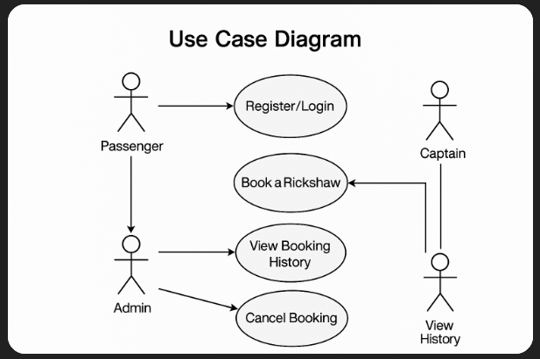

Fig. 2: Use Case Diagram Representation

## 7.2 Activity Diagram

**7.2.1 Purpose**

An Activity Diagram is a type of UML diagram used to describe the workflow or the sequence of activities in a system. In the QuickRickShaw project, the activity diagram helps to visualize the step-by-step operations involved when a user or driver interacts with the system—such as booking a ride or accepting a ride request.

**7.2.2 Key Scenarios Modeled**

For the QuickRickShaw app, activity diagrams were created for two main roles:

a) Passenger Booking a Ride

* Start → Open App
* Login/Register
* Enter Pickup and Drop Location
* Check Available Drivers
* Confirm Ride Request
* Wait for Driver Acceptance
* Get Ride Status Updates
* Ride Completion
* Submit Feedback
* End

b) Driver Accepting a Ride

* Start → Open App
* Login/Register
* Receive Ride Notification
* Accept or Reject Ride
* Pick Up Passenger
* Complete Ride
* View Earnings
* End

**7.2.3 Activity Diagram Representation**

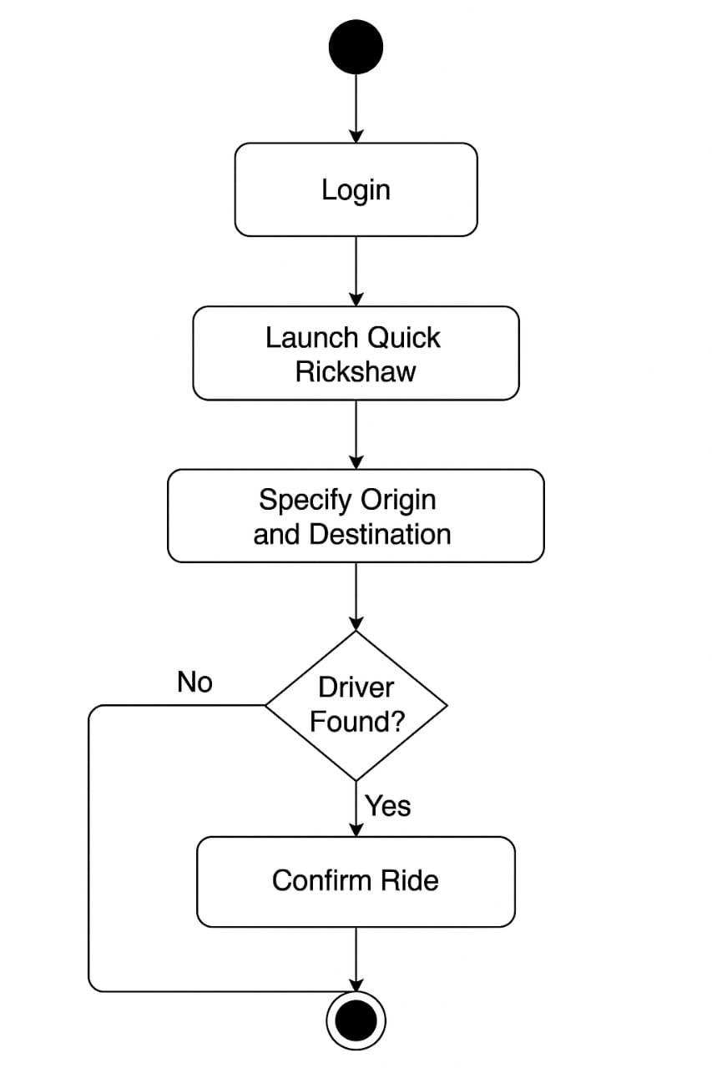

Fig. 3:Activity Diagram Representation

## 7.3 Sequence Diagram

**7.3.1 Purpose**

A Sequence Diagram is a type of UML (Unified Modelling Language) diagram that shows how objects or components in a system interact with each other over time. It focuses on the order of messages exchanged between the components to perform a specific use case or function.

In the QuickRickShaw project, the sequence diagram is used to represent the step-by-step interaction between the system components (like Passenger, Driver, Backend Server, and Database) during important operations such as booking a ride or accepting a ride. This helps visualize the timing and flow of communication between different parts of the application.

The main objectives of using a sequence diagram are:

* To analyse and validate the logic of complex processes.
* To ensure proper communication flow between system entities.
* To provide a blueprint for developers during backend API implementation.

**7.3.1 Representation of the Sequence Diagram**

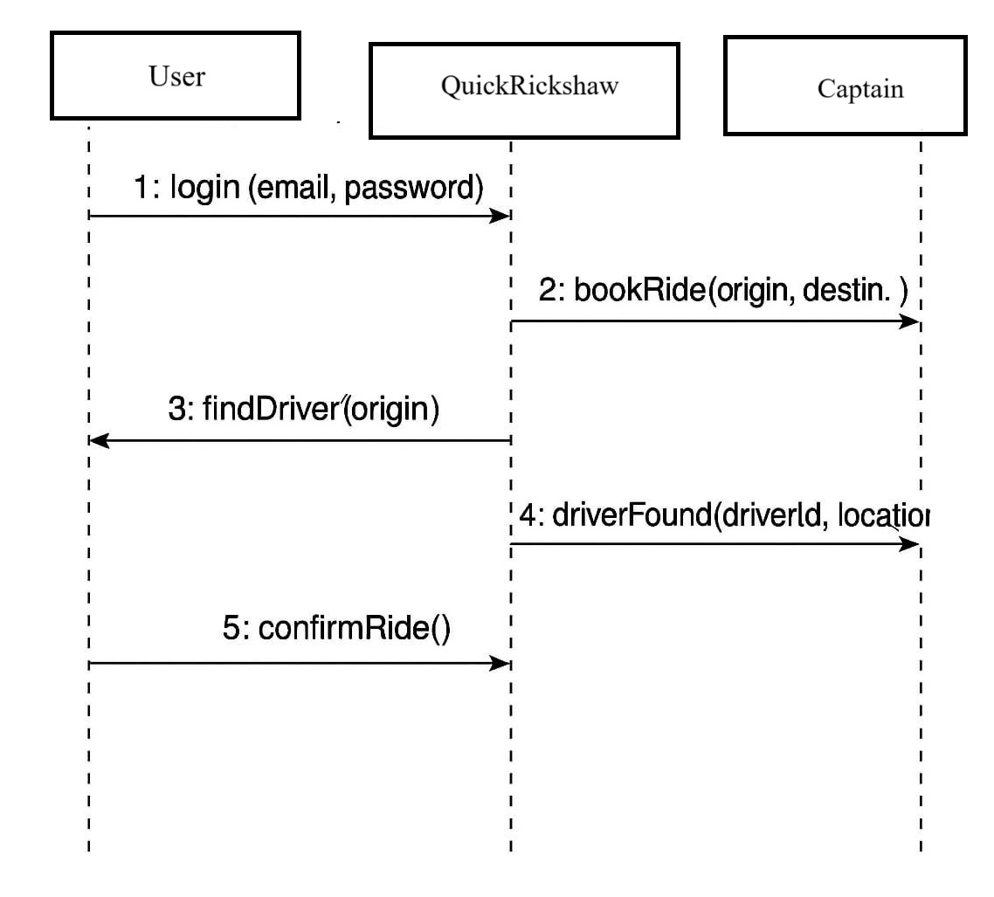

Fig. 4:Sequence Diagram Representation

## 7.4 Data Flow Diagram (DFD)

**7.4.1 Purpose**

Explain that DFD shows how data moves through the system, helping understand system inputs, processes, and outputs.

**7.4.2 Levels of DFD**

* Level 0 (Context Level): Show high-level data exchange between users and system.
* Level 1 (Detailed Level): Show subsystems like Login, Booking, Driver Management, etc.

**7.4.3 Representation of the Data Flow Diagram**

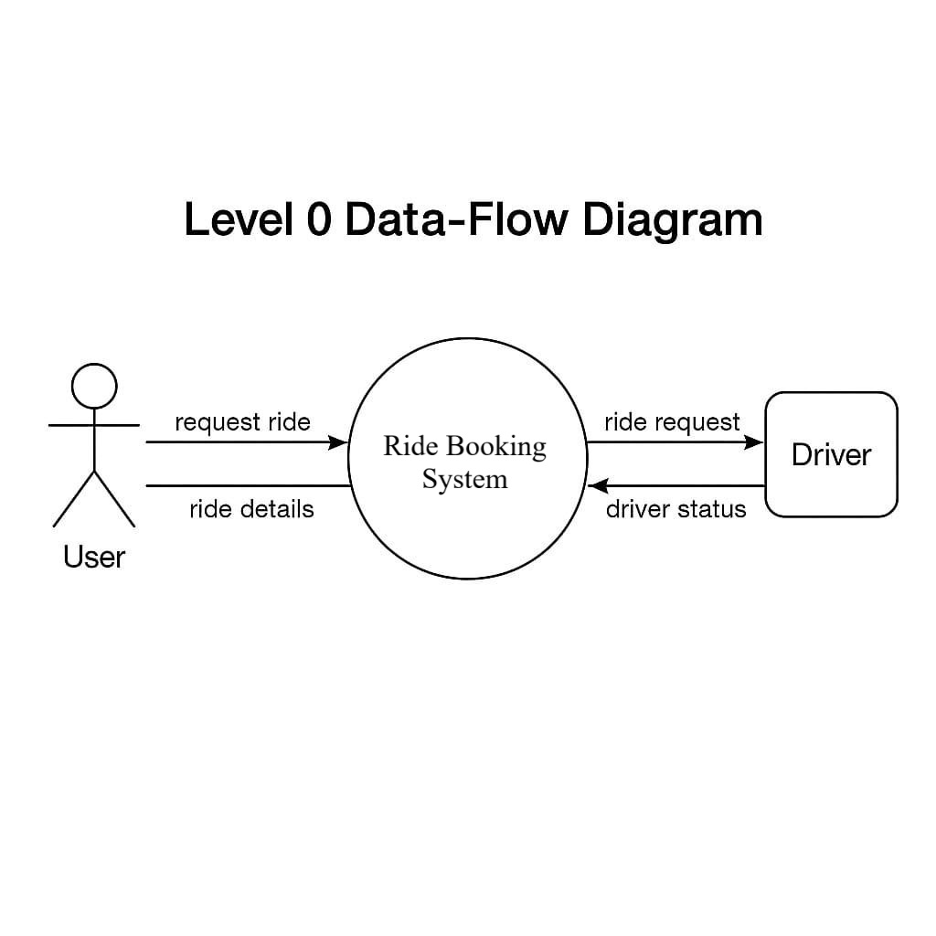

Fig. 5:Data Flow Diagram Level 0

Fig. 6:Data Flow Diagram Level 1

## 7.5 ER Diagram (Entity–Relationship Diagram)

**7.5.1 Purpose**

The ER Diagram is used to represent the logical structure of the database in the QuickRickShaw project. It helps visualize the entities involved in the system, their attributes, and the relationships between them. This diagram acts as a blueprint for designing the backend database using MongoDB.

In QuickRickShaw, the ER diagram models how users, drivers, rides, and feedback are connected, and how data flows between these elements.

* Rectangles for entities (User, Driver, Ride, Feedback)
* Ovals for attributes
* Diamonds for relationships (e.g., “User”, “Driver”)

**7.5.2 ER Diagram Representation**

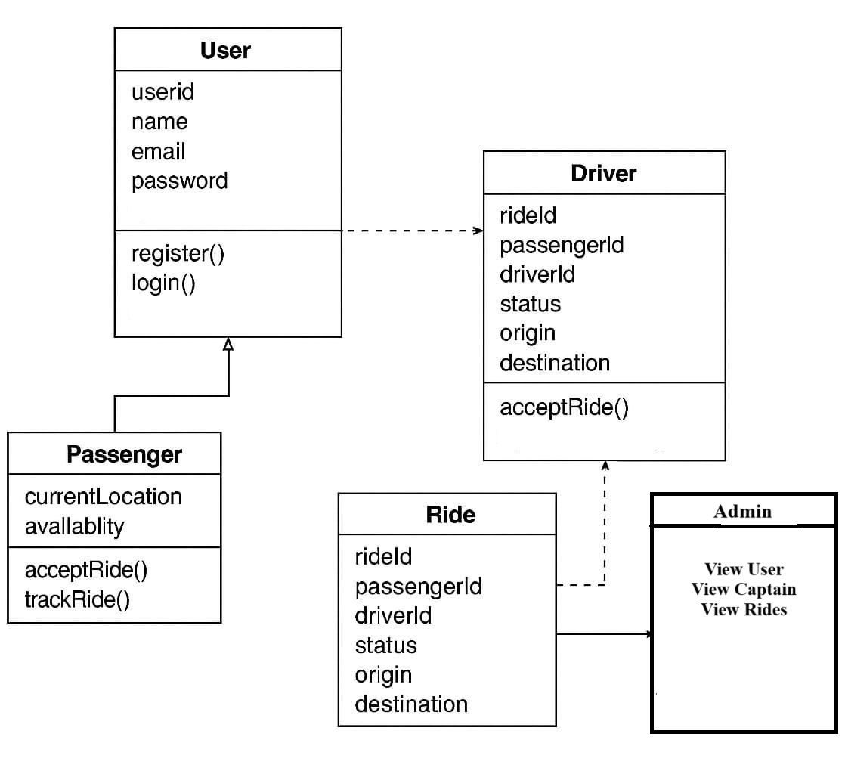

Fig. 7:ER Diagram Representation

# 8. System Implementation and Screenshots

This chapter demonstrates the practical implementation of the QuickRickShaw application by presenting screenshots of key features and describing their functionality. It helps validate that the project is working as expected and matches the design and requirement specifications.

## 8.1 Screenshot

**8.1.1 User Registration and Login**

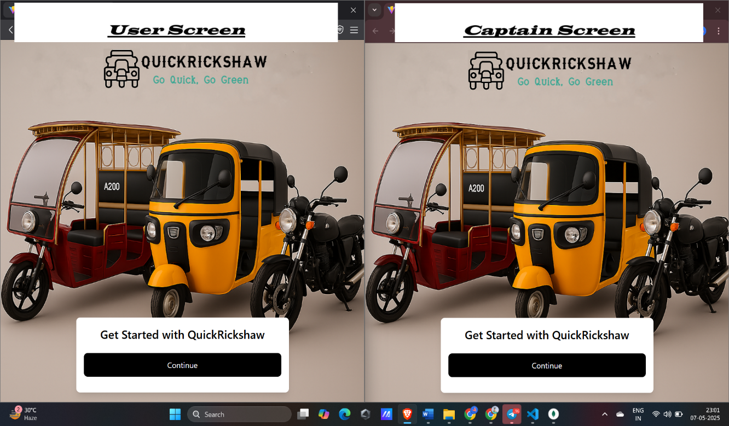

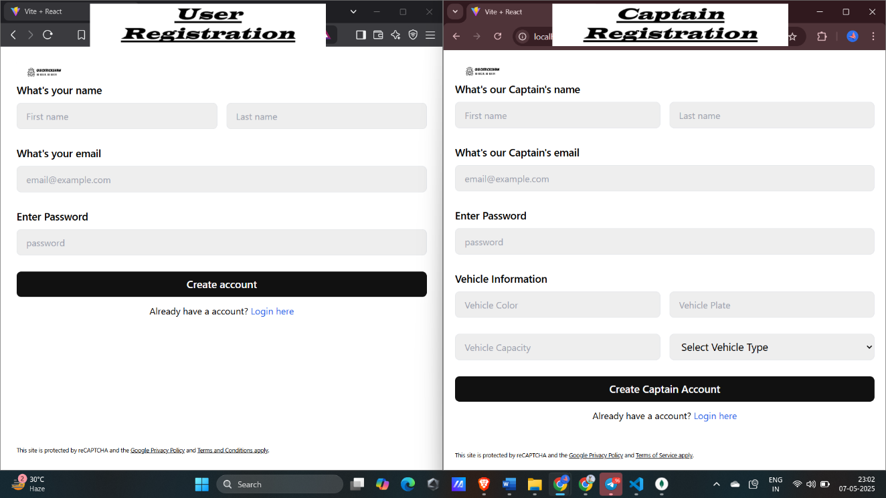

Fig. 8: User Registration and Login

**8.1.2 USER/CAPTAIN Home Page**

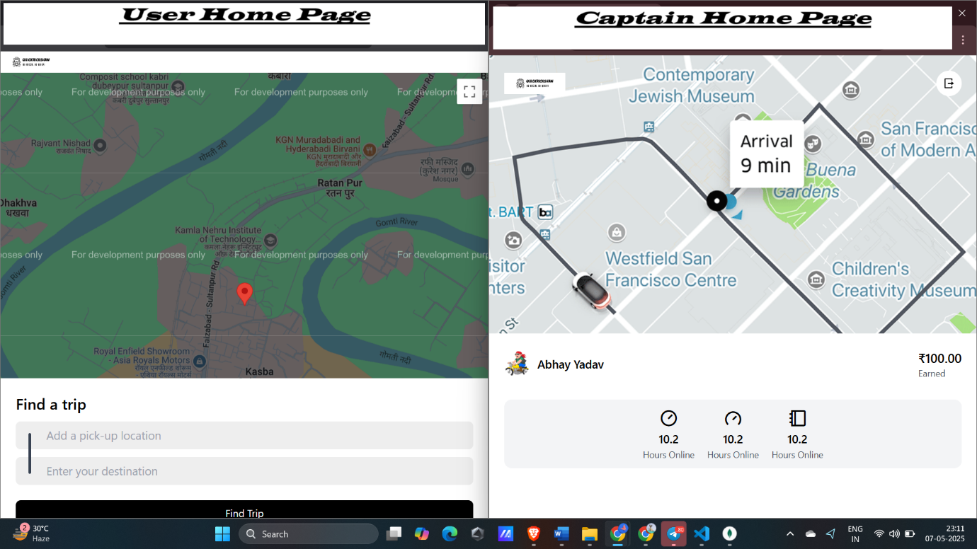

Fig. 9: USER/CAPTAIN Home Page

**8.1.3 Auto Suggestions GOMAPS API (Source)**

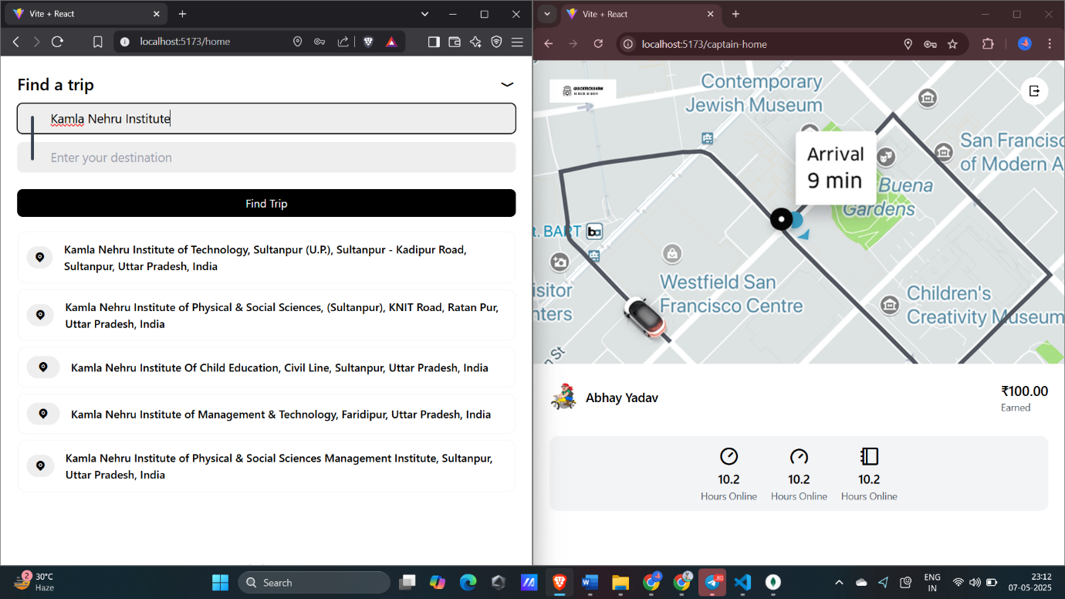

Fig. 10: Auto Suggestions GOMAPS API(Source)Page

**8.1.4 Auto Suggestions GOMAPS API (Destination)**

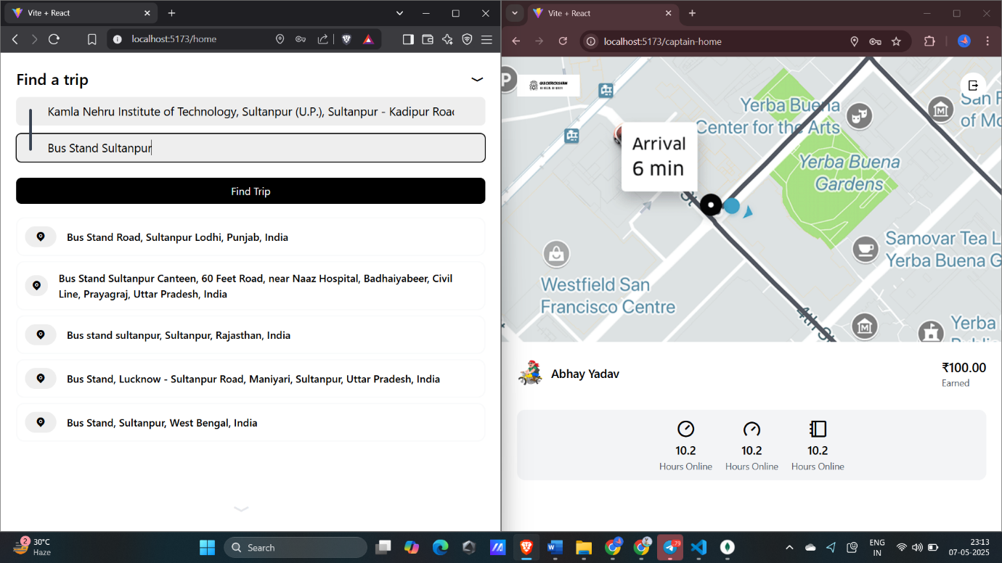

Fig. 11: Auto Suggestions GOMAPS API (Destination)Page

**8.1.5 Fare Display**

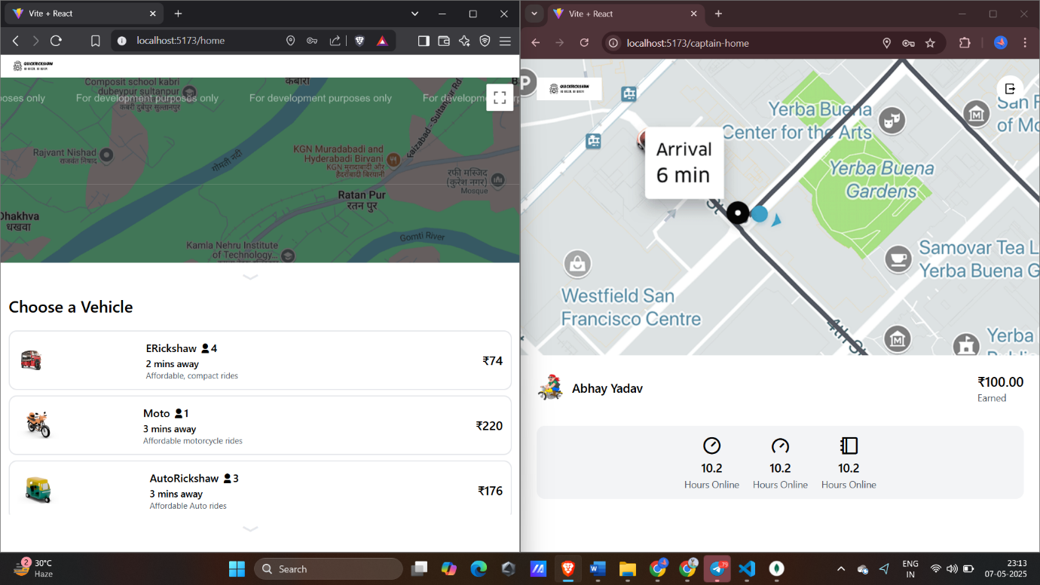

Fig. 12: Fare Display Page

**8.1.6 Confirm Ride Popup**

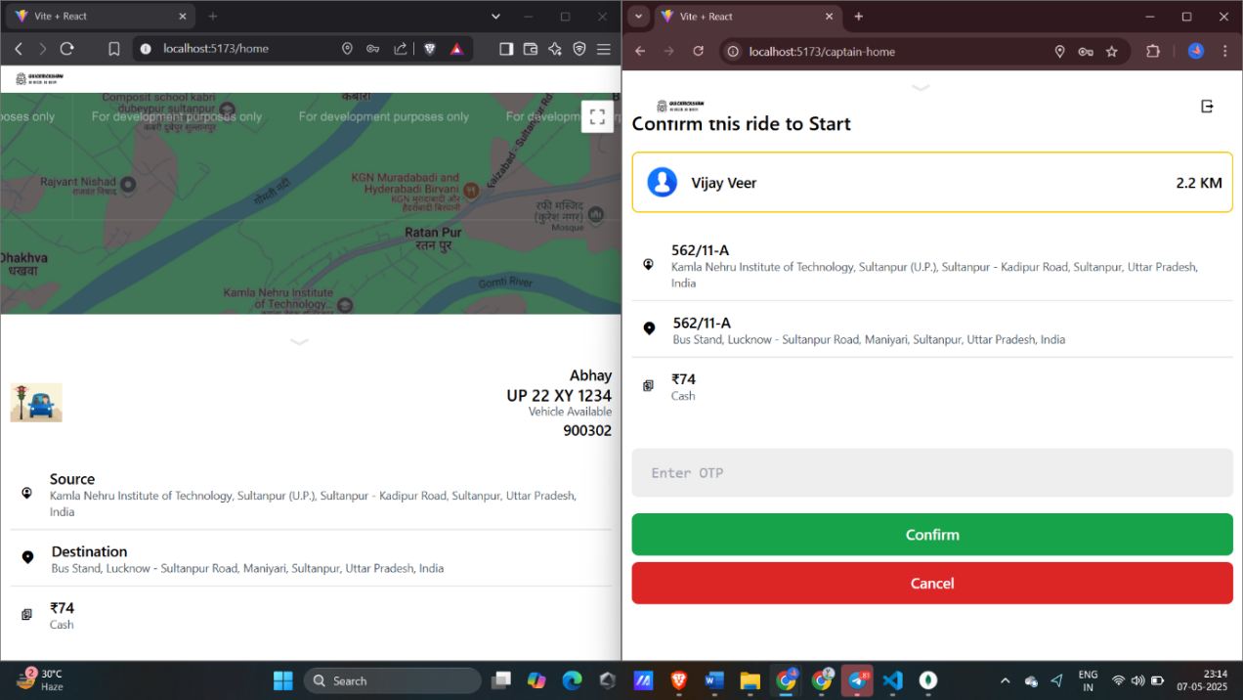

Fig. 13: Confirm Ride PopupPage

**8.1.7 Accept Ride Popup**

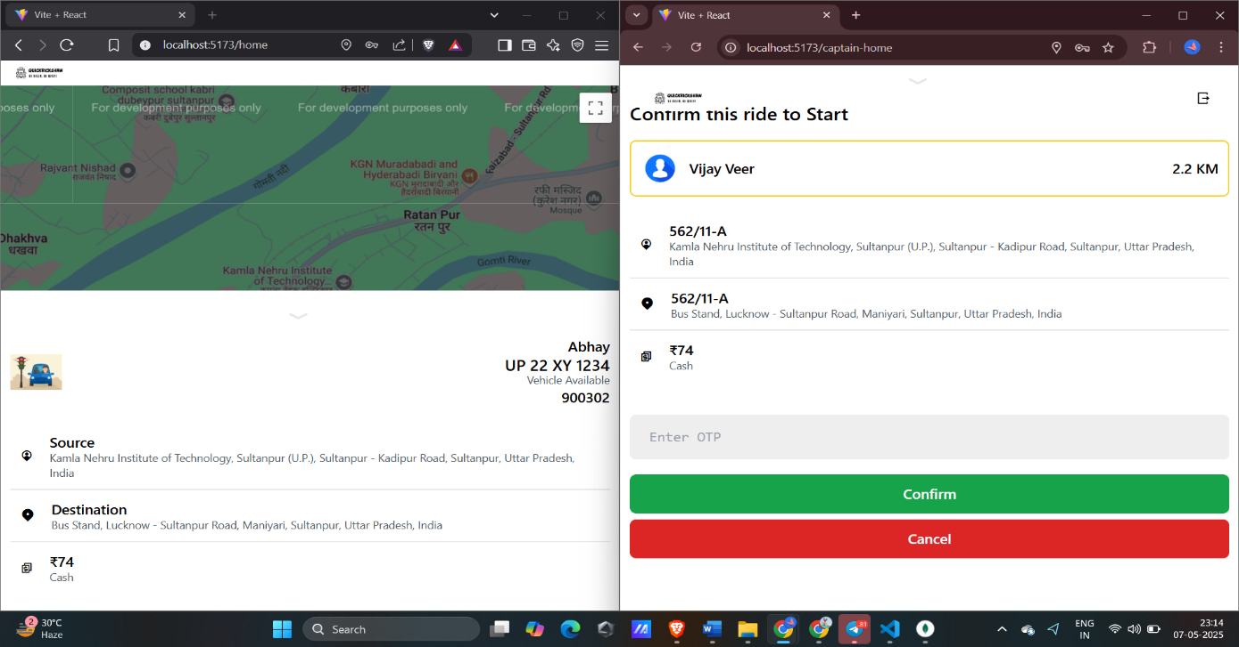

Fig. 14: Accept Ride PopupPage

**8.1.8 Complete Ride**

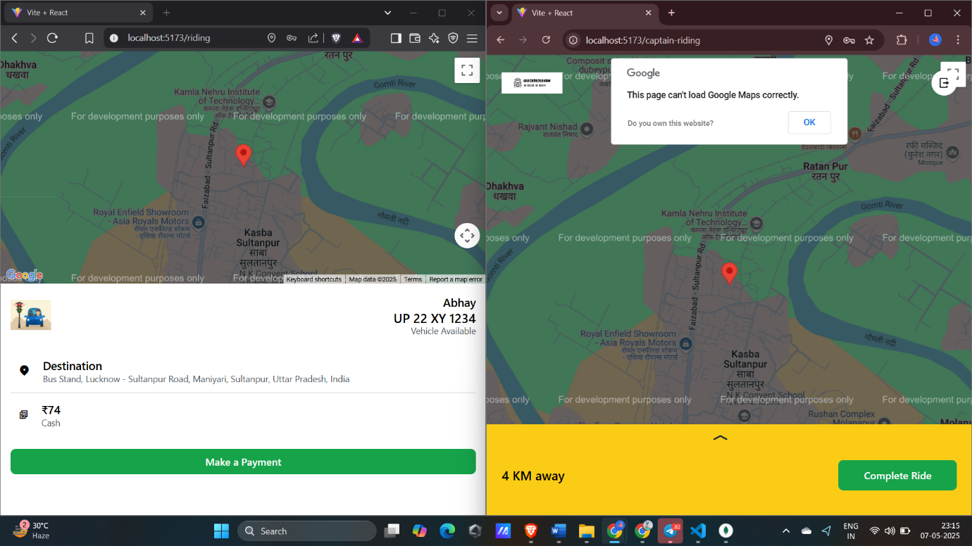

Fig. 15: Complete RidePage

**8.1.9 Database Representation**

Fig. 16: Database Representation

# 9. Conclusion and Future Scope

### ****9.1 Conclusion****

The QuickRickshaw project is a significant step toward modernizing local transportation using emerging web technologies. By offering a user-friendly, digital platform that connects passengers with rickshaw drivers, the app solves many problems faced in conventional transport systems—such as long wait times, fare disputes, and lack of transparency.

Built on the robust and scalable MERN stack, the application demonstrates strong performance, modular design, and the potential for future expansion. The use of MongoDB allows for flexible data modelling, React ensures a responsive and intuitive UI, Node.js provides a fast backend runtime, and Express simplifies server-side routing and middleware integration.

In a broader context, QuickRickshaw contributes to the concept of smart cities by digitizing and organizing informal transport. It empowers both passengers and drivers, promotes sustainable transport, and supports economic growth in urban and semi-urban areas.

As urban mobility continues to evolve, QuickRickshaw has the potential to scale up, integrate new technologies, and play a key role in transforming the way people move within cities. With further development, the app can become a widely adopted solution that aligns with government initiatives like Digital India and Smart Mobility.

* Integration of Real-Time Tracking: In the future, GPS-based live tracking can be added to help users locate nearby rickshaws and follow their routes in real time.
* Digital Payment Options: Currently, the app may use cash transactions, but future updates could include UPI, wallets, or debit/credit card integration for seamless payments.
* Driver and User Rating System: Adding a basic review and rating feature will help improve trust and service quality by allowing feedback from both users and drivers.
* Multi-City Deployment and Scalability: The current system can be scaled and deployed in other cities by modifying area-specific configurations and expanding the driver base.
* Admin Panel for Fleet and User Management: A future admin dashboard could provide tools to monitor drivers, trips, complaints, and system performance, enhancing overall control.

**9.2 Future Scope**

The future scope of *QuickRickshaw* is promising, especially considering the rapid growth of urban areas, the demand for sustainable transportation, and the increasing integration of digital technologies in daily life. As a digital rickshaw booking platform built using the MERN stack (MongoDB, Express.js, React.js, and Node.js), QuickRickshaw addresses core problems like unorganized local transport, lack of availability, unfair pricing, and poor user-driver communication. Looking ahead, there are several areas where the platform can evolve and expand:

1. Integration of Real-Time Tracking and GPS: Enhancing the app with GPS-based real-time tracking of rickshaws will allow users to see nearby drivers and get accurate ETA (Estimated Time of Arrival). This would not only improve user experience but also build trust in the platform.
2. AI-Powered Fare Estimation and Route Optimization: Machine learning models can be introduced to predict fare based on time, distance, and traffic conditions. Route optimization algorithms can help drivers avoid congested routes, reducing travel time and fuel costs.
3. Driver Performance and Ratings System: Introducing a robust rating and feedback system for both drivers and passengers would help maintain service quality and identify reliable users. Gamification and incentive systems can also be added to reward high-performing drivers.
4. Multi-language Support: Given the linguistic diversity of India and other developing nations, incorporating multi-language support will make the app more accessible to a wider audience, including rural and semi-urban users.
5. Payment Gateway Integration: Currently, many local transport systems rely on cash transactions. By integrating secure online payment gateways and UPI (Unified Payments Interface), QuickRickshaw can modernize the payment process, offering a smoother cashless experience.
6. Scalability to Other Transport Modes: While the current focus is on rickshaws, the platform can be easily extended to include other low-cost transport options such as e-rickshaws, bike taxis, and small vans, making it a comprehensive local transport app.
7. Edge Computing and IoT Integration: Since the idea is inspired by Mobile Edge Radio Technology (MERT), future enhancements could involve edge computing for faster, decentralized processing, and the integration of IoT devices to monitor vehicle health, fuel usage, and safety alerts.

# 10. References

1. MongoDB Inc. (2023). *MongoDB Documentation*. <https://www.mongodb.com/docs/>
2. Express.js. (2023). *Express Web Framework (Node.js)*. <https://expressjs.com/>
3. Meta (React). (2023). *React – A JavaScript library for building user interfaces*. <https://react.dev/>
4. Node.js Foundation. (2023). *Node.js Documentation*. https://nodejs.org/en/docs/
5. W3Schools. (2023). *MERN Stack Tutorial*. https://www.w3schools.com/whatis/whatis_mern.asp
6. NITI Aayog & Rocky Mountain Institute. (2017). *India Leaps Ahead: Transformative Mobility Solutions for All*. <https://niti.gov.in/>
7. Ministry of Housing and Urban Affairs. (2020). *Smart Cities Mission Guidelines*. <https://smartcities.gov.in/>
8. World Bank. (2021). *Transforming Transportation in India*. <https://www.worldbank.org/>
9. Kumar, A., & Zimmerman, S. (2008). *Transport and Urban Poverty in India: A Case Study of Mumbai*. World Bank Publications.
10. ITDP India. (2022). *Improving Urban Transport Systems*. <https://www.itdp.in/>
11. Nielsen Norman Group. (2022). *Usability Heuristics for Mobile Applications*. <https://www.nngroup.com/articles/mobile-ux/>
12. Google Developers. (2023). *Progressive Web Apps (PWA)*. <https://web.dev/progressive-web-apps/>
13. Firebase. (2023). *Mobile Backend Solutions*. <https://firebase.google.com/>
14. Statista. (2023). *Mobile App Usage in India*. <https://www.statista.com/>
15. Government of India. (2023). *Digital India Programme*. <https://digitalindia.gov.in/>
16. MEITY (Ministry of Electronics and Information Technology). (2023). *e-Governance Initiatives*. <https://www.meity.gov.in/>
17. TRAI. (2023). *Mobile Connectivity and Internet Usage in India*. <https://trai.gov.in/>
18. Ghosh, S. (2014). *Auto-Rickshaws in Indian Cities: A Regulatory Challenge*. Indian Journal of Transport Management.
19. Basu, S., & Maitra, B. (2015). *Informal Paratransit Systems in India: A Case Study of Auto-Rickshaws in Kolkata*. Transportation Research Record.
20. Singh, S.K. (2005). *Review of Urban Transportation in India*. Journal of Public Transportation, 8(1), 79–97.
21. Shi, W., Cao, J., Zhang, Q., Li, Y., & Xu, L. (2016). *Edge Computing: Vision and Challenges*. IEEE Internet of Things Journal.
22. Kaur, P., & Singh, M. (2021). *Role of IoT in Smart Transportation*. Journal of Advanced Research in Dynamical and Control Systems.
23. Uber Technologies. (2023). *Mobility Platform Overview*. <https://www.uber.com/>
24. Ola Cabs. (2023). *About Ola and Digital Transport Solutions*. <https://www.olacabs.com/>
25. Rapido. (2023). *Bike Taxi Service & User Interface Approach*. <https://www.rapido.bike/>